|  |  |  |
| --- | --- | --- |
|  | **Project Design Phase-I** | |
|  | **Solution Architecture** | |
|  |  |  |
| Date |  | 14th October 2022 |
| Team ID |  | PNT2022TMID31240 |
| Project Name |  | Project – Natural Disaster Intensity Analysis and |
|  |  | Classification Using Artificial Intelligence |
| Maximum Marks |  | 4 Marks |

**Solution Architecture:**

Solution architecture is a complex process – with many sub-processes – that bridges the gap between business problems and technology solutions. Its goals are to:

* Find the best tech solution to solve existing business problems.
* Describe the structure, characteristics, behavior, and other aspects of the software to project stakeholders.
* Define features, development phases, and solution requirements.
* Provide specifications according to which the solution is defined, managed, and delivered.

**Example - Solution Architecture Diagram:**

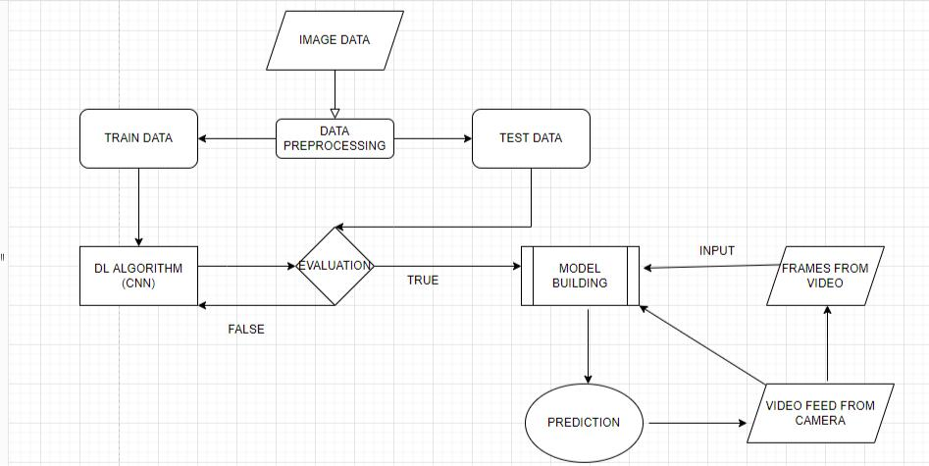

Fig 1. Architecture and Flow Diagram to classify the natural disaster using Deep Learning Algorithms

**Submitted by:**

K.Vignesh (621519106078)

M.MadhanKumar (621519106301)

N.Manoj (621519106042)

M.VijayBharat (621519106080)